Transportation & mobility – transportation
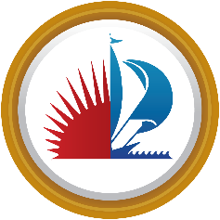

Title VI Creole Notice to the Public

Notice to Public (French Creole)

Anons Pou Piblik La:

City of Fort Lauderdale opere pwogram transpotasyon ak sevis li yo san gade sou ras, koule, ak peyi orijin moun konfomeman ak Tit VI nan Lwa Dwa Sil la. Nenpot moun ki kwe yo te fe yon pratik diskriminasyon ilegal kont li sou Tiv VI kapab depoze yon plent ak City of Fort Lauderdale .
Pou plis enfomasyon sou pwogram dwa sivil City of Fort Lauderdale la, ak pwosedi pou depoze yon plent, kontakte Milos Majstorovic nan 954-828-5216 imel mmajstorovic@fortlauderdale.gov oswa vizite biwo administratif nou nan 290 NE 3rd Avenue, Fort Lauderdale,FL 33311 or https://www.fortlauderdale.gov/government/departments-a-h/human-resources/human-resources-administration/risk-management/title-vi .
Yon moun k ap depoze yon plent kapab voye li direkteman bay Depatman Edikasyon Florida. Pou fe sa depoze plent la ak Kodonatris Distri 4 Tit VI Adrienne Brown nan adrienne.brown@dot.state.fl.us

Title VI Program

